
Facilitator Guide

Module 11 – , Fundamentals of Design Thinking and Innovation
Occupational Certificate: Artificial Intelligence Software Developer

Module # | 251201-002-00-KM-11
NQF Level | 4
Notional hours | 10
Credit(s) | 1
Curriculum Code | 251201002
Qualification Title | Occupational Certificate: Artificial Intelligence Software Developer

CONTACT INFORMATION:
Name
Contact Address
Telephone (H)
Telephone (W)
Cellular

PURPOSE OF THE KNOWLEDGE MODULE
The main focus of the learning in this knowledge module is to build an understanding of the design thinking principles and applications in the workplace

PROVIDER ACCREDITATION REQUIREMENTS FOR THE MODULE:

Physical Requirements:
- The provider must have lesson plans and structured learning material or provide learners with access to structured learning material that addresses all the topics in all the knowledge modules as well as the applied knowledge in the practical skills.
- QCTO/ MICT SETA requirements
Human Resource Requirements:
- Lecturer/learner ratio of 1:20 (Maximum)
- Qualification of lecturer (SME):
- NQF 6 in industry recognised qualifications with 1 year’s experience in the IT industry
- AI vendor certification (where applicable)
- Assessors and moderators: accredited by the MICT SETA
Legal Requirements:
- Legal (product) licences to use the software for learning and training (where applicable)
- OHS compliance certificate
- Ethical clearance (where necessary)
Exemptions
- No exemptions, but the module can be achieved in full through a normal RPL process

TOPIC ELEMENTS TO BE COVERED INCLUDE:
- KM-11-KT01 : Introduction to design thinking
- KM-11-KT02 : The human element
- KM-11-KT03 : Creativity
- KM-11-KT04 : Innovation
- KM-11-KT05 : Design
- KM-11-KT06 : Design thinking methodology
- KM-11-KT07 : Application of design thinking

SECTION 1: 11-KT01: Introduction to design thinking

Explain the concepts of design thinking?
Design thinking is a process for solving problems by prioritizing the consumer's needs above all else. It relies on observing, with empathy, how people interact with their environments, and employs an iterative, hands-on approach to creating innovative solutions.

Identify 5 terms used for design thinking?
The five stages of Design Thinking, according to d.school, are as follows: Empathise, Define (the problem), Ideate, Prototype, and Test.

SECTION 2: KM-11-KT02:The human element

What are human-centered design methods?

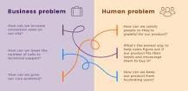

Human-centered design is a methodology for devising successful design solutions. According to this methodology, UX designers focus on end-users from the very beginning of product creation and have users testing each iteration of a product. As a result, end-users get a product that satisfies their needs.

SECTION 3: KM-11-KT03: Creativity

Outline the difference between creativity and innovation

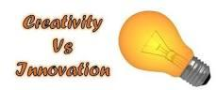

Creativity is an act of creating new ideas, imaginations and possibilities. Innovation is the introduction of something new and effective into the market.

What are examples of creativity?
Examples of creativity skills
- Making connections.
- Asking questions.
- Making observations.
- Networking.
- Experimenting.

Explain the applications of creative thinking?
Creative thinking is about bringing divergent and convergent thinking together. Divergent thinking is finding many answers to a problem, and techniques such as brainstorming and mind mapping are effective in mapping out the mundane, eliminating them and then starting to see new connections and patterns.

SECTION 4: KM-11-KT04: Innovation

What are the 4 different types of innovation?

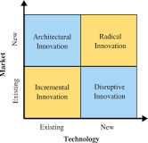

The four different types of innovation mentioned here – Incremental, Disruptive, Architectural and Radical – help illustrate the various ways that companies can innovate. There are more ways to innovate than these four.

What is example of incremental innovation?



Incremental innovation doesn't create new concepts or products, as it focuses on marginal improvements to what already exists. For example, Gillette constantly upgrades its razors, adding new features, like extra blades, heated razors, and a pivoting head.

What is process innovation and examples?
For example, the introduction of a completely new sequence to an existing production process that speeds production by 100%, thereby saving the organization money and time, could be considered a process innovation.

According to Business Dictionary, “product innovation” is defined as “the development and market introduction of a new, redesigned, or substantially improved good or service.” It's not only about developing something new and original, it's also about taking what's already there and making it much better.

What is product innovation and examples?



Product innovation in new products involves making something that solves a problem in a new and exciting way. Product innovation in improved products involves introducing better or more functionality to existing products. Examples include the following: Electric and gas lawn mower. GPS in cars.

An organisational innovation is the implementation of a new organisational method in the firm's business practices, workplace organisation or external relations.

Identify different Types Of Innovation
According to the 4th and most recent edition (2018) of the Oslo Manual, there are four main types of innovation:
Organizational Innovation
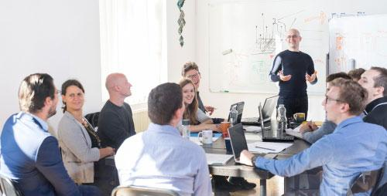
Organizational innovation refers to the development of a new organizational strategy that will somehow change a company’s business practices, as well as the way its workplace is organized and its relationship with external stakeholders.

What is process Innovation

Process innovation is about implementing a new or improved production or delivery approach, including changes in operational methods, the techniques used and the equipment or software.
- Examples of process innovations:
  - The first firms betting on SaaS (software as a service) technology, and using, for instance, cloud contact centers from Talkdesk, changed the way their customer support processes used to be organized
  - The first hotels that decided to make decisions based on big data using, for instance, insights from the Climber Hotel, made changes on their decision-making approach

SECTION 5: KM-11-KT05 : Design

Why is Ideating the most important in design thinking process?
Ideation is often the most exciting stage in a Design Thinking project, because during Ideation, the aim is to generate a large quantity of ideas that the team can then filter and cut down into the best, most practical or most innovative ones in order to inspire new and better design solutions and products.

What defines shape and form?

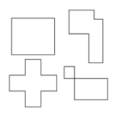

Shape vs Form
“Form” and “shape” define objects situated in space. The basic difference, though, between “shape” and “form” is that “form” is in 3D while “shape” is plain 2D. The latter is simply defined by lines. “Shape” is thus described by virtue of how many sides it has and to some degree by its angular relations.

Whats the difference between a shape and form?
In the visual arts, shape is a flat, enclosed area of an artwork created through lines, textures, colours or an area enclosed by other shapes such as triangles, circles, and squares. Likewise, a form can refer to a three-dimensional composition or object within a three-dimensional composition.

SECTION 6: KM-11-KT06 : Design thinking methodology

What are the 6 phases of design thinking?

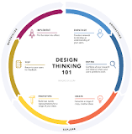

The design-thinking framework follows an overall flow of 1) understand, 2) explore, and 3) materialize. Within these larger buckets fall the 6 phases: empathize, define, ideate, prototype, test, and implement.

What are design thinking techniques?

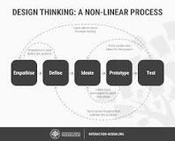

Design thinking is a non-linear, iterative process that teams use to understand users, challenge assumptions, redefine problems and create innovative solutions to prototype and test. Involving five phases—Empathize, Define, Ideate, Prototype and Test—it is most useful to tackle problems that are ill-defined or unknown.

SECTION 7: KM-11-KT07 : Application of design thinking

What is application development example?
Alternatively, it is also referred to as middleware. Application software addresses the end user and provides features to perform specific tasks and activities. Typical examples are programs for document creation and storage, image processing, movie or music playback, etc.

What is application software with example?
An application program (application or app for short) is a computer program designed to carry out a specific task other than one relating to the operation of the computer itself, typically to be used by end-users. Word processors, media players, and accounting software are examples.

What is application security and examples?

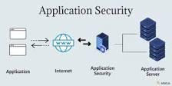

Authentication, authorization, encryption, logging, and application security testing are all examples of application security features. Developers can also use code to reduce security flaws in applications.

Give an example of business innovation?



Examples of product innovations:
The first electric vehicles introduced in the car's market were also an innovation, and new batteries with longer ranges that keep coming out are also an example of innovation.

Why is innovation important in problem solving?
Sustaining innovation.
Most innovation happens here, because most of the time we are seeking to get better at what we're already doing. We want to improve existing capabilities in existing markets, and we have a pretty clear idea of what problems need to be solved and what skill domains are required to solve them.

